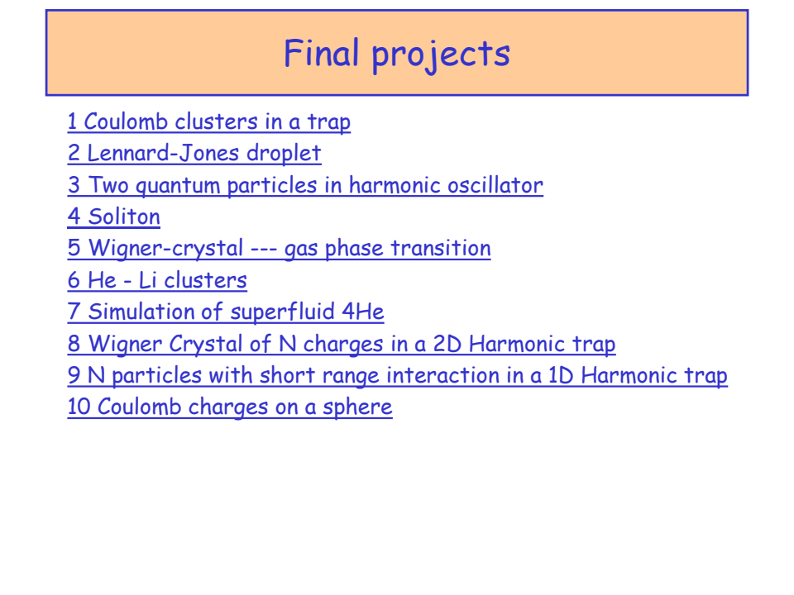

If you wish to make a presentation of any of the previous projects, or you have one of your own interest, suitable to be studied by means of Monte Carlo simulation,

add at the end of this document the title of the project and your name.

The presentation should take 15-20 minutes, followed by a short discussion with questions or comments.

The presentation session will be held at B4-001 class-room, Friday 12th April at 11’15h.

You can include in your presentation some of the following points:

Introduction:
● Provide an overview of the scientific problem or phenomenon being investigated.
● Explain the advantages of using Monte Carlo simulation as the method for the calculation.

Theory:
● Describe the underlying physical principles or theoretical framework relevant to the problem.
● Explain how Monte Carlo methods are applied to simulate the system or process of interest.
● Discuss any assumptions or simplifications made in the simulation.

Methodology:
● Detail the steps involved in setting up and running the Monte Carlo simulation.
● Specify the parameters and variables used in the simulation.
● Explain any algorithms or techniques employed for generating random numbers or sampling the system.
● Describe how the system or model is represented in the simulation.
Discuss any initial conditions or boundary conditions applied to the simulation.

Results:
● Present the main findings of the Monte Carlo simulation.
● Include relevant data, such as histograms, scatter plots, or time series plots, to illustrate the results.
● Discuss any trends, patterns, or interesting features observed in the simulation output.

Discussion:
● Interpret the results in the context of the original scientific problem.
● Analyze the sources of uncertainty or error in the simulation and their potential impact on the results.

Conclusion:
● Summarize the key findings and implications of the Monte Carlo simulation.
● Highlight any insights gained or limitations of the study.
● Suggest future research directions or areas for improvement in the simulation methodology.

References (if appropriate):
● Provide citations for any relevant literature, theoretical models, or previous studies referenced in the presentation.

